Toronto Shelter Occupancy Analysis vs Weather Impact

**University of Toronto**

**3250 Data Science Foundation**

**Group 4**

**Group members:**

**Yunfei Bai**

**Tayfun Umman**

**Hyun Kim**

**Jessica (Yuanyuan) Zou**

Table of Contents

Background 3

Objective 3

Data Preparation 4

The Shelter Occupancy Dataset 4

The Weather Dataset 4

Dropped Columns 4

Description of Variables 5

Treatment of Missing Valuables 6

Engineered Variables 6

Challenge of the Data 6

General Analysis 7

Toronto Shelter Capacity Time Series 7

Toronto Shelter Occupancy Number Time Series and Occupancy-rate Time Series 8

Shelter Variables vs Weather Variables Study 10

Sector Analysis 13

Sector Analysis – Families 13

Sector Analysis – Male Adults 15

Sector Analysis – Female Adults 17

Sector Analysis – Youth 20

Sector Analysis – Co-ed sector 21

Conclusion 25

Appendix 28

A. Reference 28

B. Sample Data 29

C. Sample Codes 29

# Background

The City of Toronto operates more than 7000 emergency and traditional shelter beds through out the city. However, the city is also facing some challenges, it is acknowledged that demand for daily use of shelter beds increases every year.[1] There are about 5000 men, women and children using daily shelters in May 2017, and that number is increasing year by year.[2] Key elements that contribute to increasing demand for shelter use are from diverse social, economical and political situations; the decline in income, high rental cost, decreased government funding, high influx of refugee claimants and public health issues are major underlying reasons.[6][7]

Furthermore, a recent news report is also suggestive that demand for shelter beds spikes when weather gets colder. According to the news report, these recent complaints about inadequate shelter beds for those who need daily in the city during the cold winter months caused the City of Toronto to launch a formal investigation. [4] In Calgary, a new study conducted by the University of Calgary shows that demand is high not only with extreme cold temperature but also when weather turns unpleasant with rain, wet snow and sleet, particularly in the spring and fall.[8]

Based on these claims, data analytic objective and study hypothesis are defined to study daily shelter use data influenced by weather conditions.

# Objective

The goal of following data analysis is to observe what trends, statistical characteristics such as correlations or data patterns exist between daily shelter occupancy rate and daily weather data in Toronto.

The hypothesis of this analysis is that severe weather conditions such as cold or hot temperatures, heavy rain and snow have direct impact on increased use of daily shelters in Toronto.

The analysis framework for shelter usage and weather include following:

* Obtain the public open data from the city of Toronto on daily shelter occupancy.
* Obtain the public historical weather data from Environment Canada.
* Use Jupyter notebook to perform data cleaning and transformation, statistical analysis, data visualization to describe data set.
* Draw conclusions based on the analysis to accept or reject the hypothesis.

# Data Preparation

This study is based on two major data sources: shelter occupancy dataset and weather dataset. The two datasets are merged based on dates. The shelter dataset is limited to 2017 daily data and half year 2018. This study is using 2017 full year daily data.

## The Shelter Occupancy Dataset

The shelter occupancy dataset is an open data and downloaded from the City of Toronto website. The dataset provides a listing of all the active shelters serving the City of Toronto area. Included in the dataset is the name of the shelter, program name, sector served (i.e. men, women, youth, families) addresses, the space capacity (i.e. beds or cots available) and the number of people that occupied those spaces at 4:00 AM the next morning. Our study groups the occupancy and capacity by the date. Later in the study we repeated the similar analysis based on the sector served.

## The Weather Dataset

We located the historical data of past weather and climate using the government of Canada website. The website provides the capability to search by stations, by province or by proximity. Due to the limitation of shelter occupancy dataset, we chose Toronto station as the scope of weather dataset. For this study, we select data interval as daily instead of hourly or monthly.

The weather dataset contains the following variables: maximum temperature, minimum temperature, mean temperature and flag, Heat Deg Days (°C), Cool Deg Days (°C), Total Rain Flag, Total Snow Flag, Total Precip (mm), and Snow on Grnd (cm), Dir of Max Gust Flag, Spd of Max Gust Flag. Each numerical variable comes with a flag variable in pairs.

## Dropped Columns

The purpose of this study is to analyze the relationship between shelter occupancy vs weather. We decided that the property details like location, postal codes, name of the facility, name, program names would not add much value to the analysis. Therefore, these columns are dropped in this study. Sector, Occupancy and Capacity are the three variables are kept for the analysis. The value is grouped by dates.

In the weather dataset, every numerical variable goes with a flag to indicate the status of the numerical variable. For example, column ‘Max Temp Flag’ has M, or E or A to indicate missing, estimated or accumulated. With actual observation, the value for the flag is Null. For Max, Min and Mean temperature variables, the missing variables are less than 10 records out of 365 records in total, the flag variables don’t provide any value added to the magnitude of the variables. Therefore, the decision is made to drop all the flag variables in this study. In addition, there is no observation in the ‘total snow’ and ‘total rain’ columns. These two variables with their flag columns are all dropped.

## Description of Variables

Occupancy is a point in time number at 4 AM of the next day. For example, the occupancy count of January 1st would be taken on January 2nd at 4 AM. Occupancy has 365 counts after group by the dates, no missing values. Range from 4,261 to 5,537. Mean is 4,893 with standard deviation of 346, i. e most of the values are within 7% of the mean.

Capacity refers the term "spaces available" which mean a bed or a mat/cot. In the family sector it is possible to exceed available capacity depending on the bed configuration of each room. For example, a family of five, who have small children, can elect to be accommodated in a room with four beds. This situation would keep the family united but would exceed the set capacity of the database.

Variable Capacity has 365 records after group by the dates, no missing values. Range from 4,653 to 5,755. Mean is 5156 with standard deviation of 316.

Maximum temperature (numerical): this variable has 357 records in a range of (-13.7, 31.7), 8 missing value. Mean is 13.6 C, with standard deviation of 10.7.

Minimum temperature (numerical): this variable has 361 records in a range of (-20.2, 21.5),4 missing value. Mean is 6.1 C, with standard deviation of 9.4.

Mean temperature (numerical): this variable has 355 records in a range of (-17, 26.5), 10 missing value. Mean is 9.9 C, with standard deviation of 10.0.

Total Precip (mm) (numerical): Precipitation is any product of the condensation of atmospheric water vapor that falls under gravity [9]. The main forms of precipitation include drizzle, rain, sleet, snow, graupel and hail. This variable has 350 counts in a range of (0, 52.9)mm, 15 missing value. Mean is 2.2mm, with standard deviation of 5.6.

Snow on Grnd (cm) (numerical): meaning this variable has 60 counts in a range of (0, 17)cm, 305 missing value. Mean is 4cm, with standard deviation of 4.6cm. this particular variable doesn’t contain more than half of Non-null values but we want to include this for study as the extreme Snow/ storm would impact the occupancy intuitively.

Heat Deg Days (°C) (numerical): A ‘Heating degree day (HDD)’ is a measurement designed to quantify the demand for energy needed to heat a building [10]. It is the number of degrees that a day’s average temperature is below 65° Fahrenheit or 18 °C Celsius. In our dataset, variable “Heat Deg Days (°C)” has 355 records and 10 missing records. 99 days of the year that Heat Deg Days (°C) equal to 0 which means mean temperature is 18 °C Celsius.

Cool Deg Days (°C) (numerical): A ‘Cool Degree Days (CDD)’ is a measurement for energy needed to cool down a building when mean temperature is above 18 °C Celsius [11]. In other words, this variable calculates the delta from mean temperature to 18 °C Celsius. In the weather dataset from this study, the variable ‘Cool Deg Days’ has 10 missing values, 98 non-zero counts, range from 0 to 8.5. This indicates that 98 days in 2017 Toronto mean temperature is above 18 °C Celsius.

## Treatment of Missing Valuables

Two methodologies to fill NA data are heavily applied to this study. All variables (Maximum temperature, minimum temperature, heat degree dates and cool degree dates) related to temperature were filled using previous observation. We assume temperatures are continuous. For Snow on ground and total precipitation volumes, we are filling the NA values with zeros, assuming no rain or no snow accumulated on ground.

## Engineered Variables

‘O_Rates’: a fraction to indicate occupancy over capacity. O_Rate is range from 0.94 to 0.998 with mean of 0.97 and standard deviation of 0.01.

‘Delta temperature’: Max temperature – Min temperature

## Challenge of the Data

During the initial study to plot any variables, the time series plot contains a lot unnecessary seasonal like fluctuation. However, checking the original csv format dataset, we observe that temperatures are continuous and smoothly trending up or down. After deep dive into time series chapter, we realized one issue that data format needs to be adjusted in a proper way that Pandas can read. For example, 12/1/2017 and 13/1/2017 in original dataset indicate January 12th, 2017 and January 13th, 2017. Pandas will treat first one as December 1, 2017 and second one as January 13, 2017. Before loading these two records are only one day apart in the csv file but after loading, it was treated as 11 months apart in the dataframe. (Figure 1.0)

Our team didn’t realize this issue because changes were hidden and hard to be realized unless listing all dates with variables in the Jupyter notebook to check after merging two datasets. Checking top 5, top 20 rows of the new dataset and description won’t help so much.

Resolution: to understand the datatime correctly from the raw file, before loading ‘dayfirst=True’ option must be specified. Otherwise pandas will use the ‘month first’ default. Although resolution is simple, the impact of this confusion delayed the entire analysis for a week.

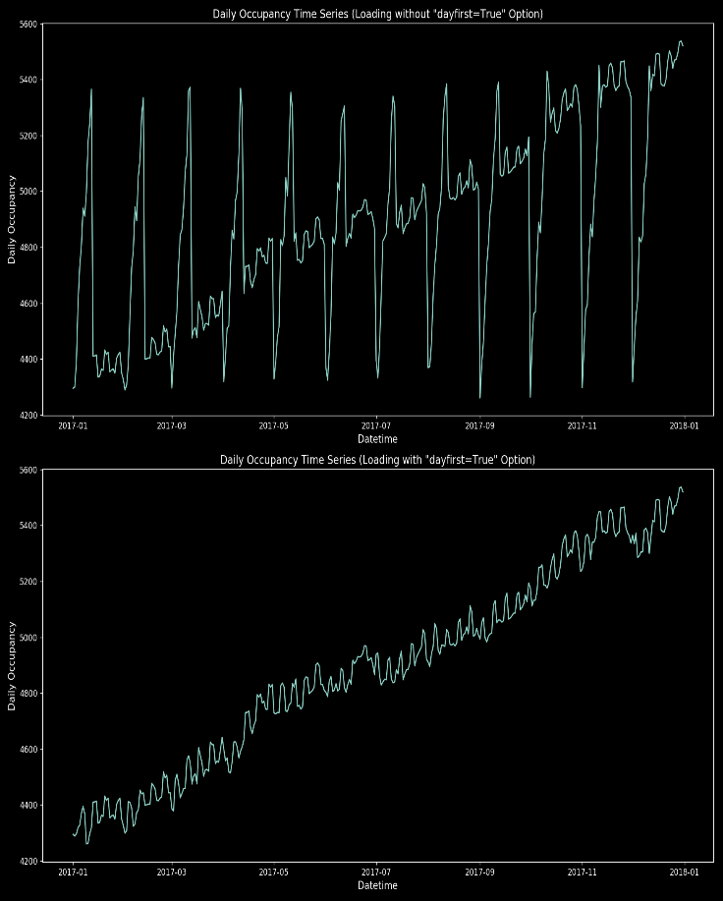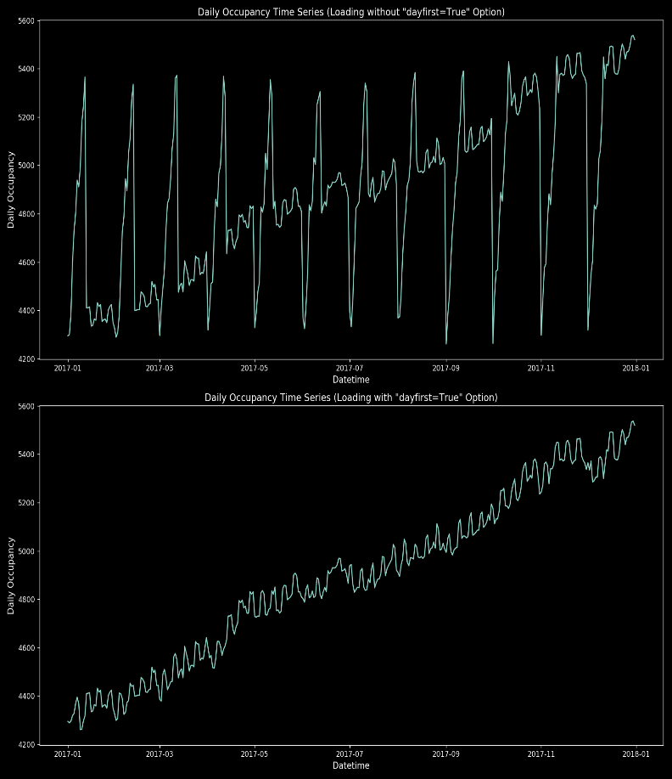

Figure 1.0 Comparison with and without dayfirst=True Option

# General Analysis

## Toronto Shelter Capacity Time Series

General capacity time series and its autocorrelation are plotted in Fig.1.1. Overall, the daily capacity of shelters in city of Toronto exhibits a stepped increasing trend. In this time series analysis, it shows a flat period from mid-January to March end. There are some relatively bigger jumps in April, June, mid-July and December end, and a fall in beginning of August. The positive autocorrelation before lag 100 also infers an increasing trend of the capacity over time. The stepped increase or drop might come from mixed factors, temperature change, season change or political decision on accommodating more refugees.

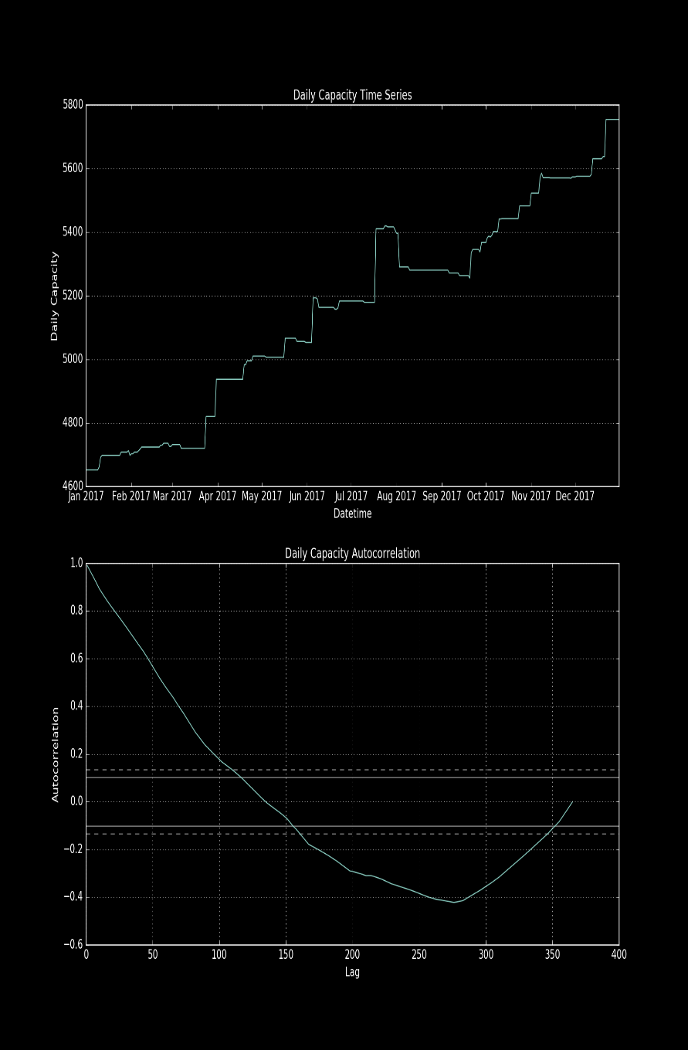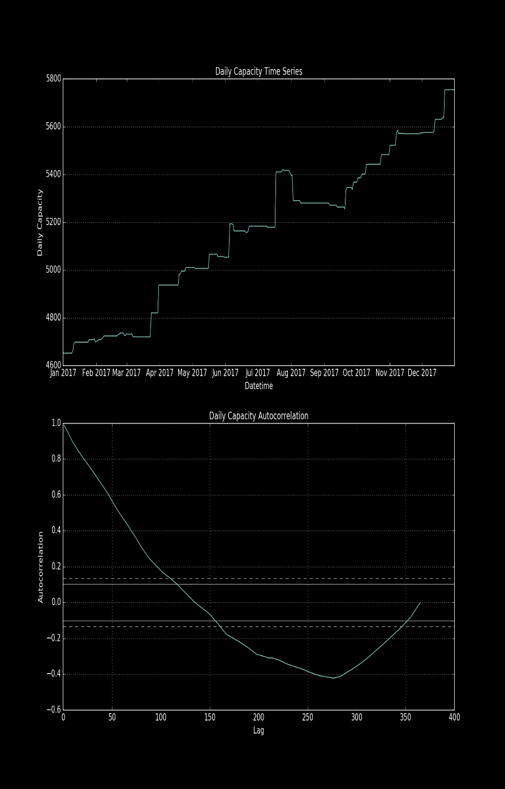

**Fig. 1.1 Capacity time series and its autocorrelation**

## Toronto Shelter Occupancy Number Time Series and Occupancy-rate Time Series

General daily occupancy-number time series and its autocorrelation are plotted in Fig.2.1. The occupancy number over the year shows an increasing trend. General daily occupancy-rate time series and its autocorrelation are plotted in Fig.2.2. The occupancy rate (occupancy over capacity) is steady over the year except for October to December, close to or even more than 100%, indicating there are more demands in shelter capacity than the actual capacity could be provided. However, unlike the capacity plot (Fig. 1.1), both occupancy and occupancy rate show an oscillating pattern. Occupancy autocorrelation pattern also slightly suggests that by having small oscillating pattern. Furthermore, when we study the occupancy rate autocorrelation in Fig.2.2, this recurring pattern is much more obvious. The autocorrelation plot of occupancy rate depicts a more obvious oscillating pattern of a seven days cycle, in which it always peaks close weekends (Friday, Saturday and Sunday). These differences between weekdays and weekends are furthermore indicated in bar plot of Days of the week Occupancy and Occupancy-rate Averages (Fig.2.3). From the graph, the average daily occupancy number for weekends (Friday, Saturday and Sunday) is almost 100 to 200 higher the weekdays, and the weekends average daily occupancy-rate is around 1-2 percent higher. Overall, in this occupancy and occupancy rate study, shelters are much more occupied over weekends (Friday, Saturday and Sunday) than other weekdays. This might indicate that some homeless could easily find other places to live during weekdays but relied more on Toronto public shelters over the weekends.

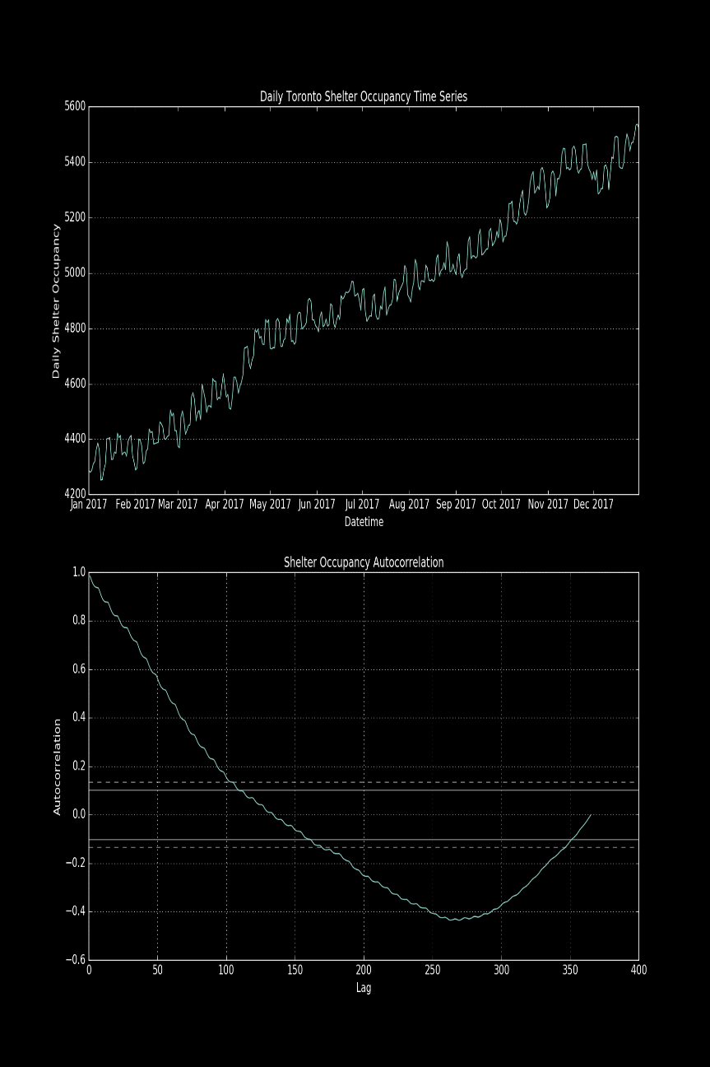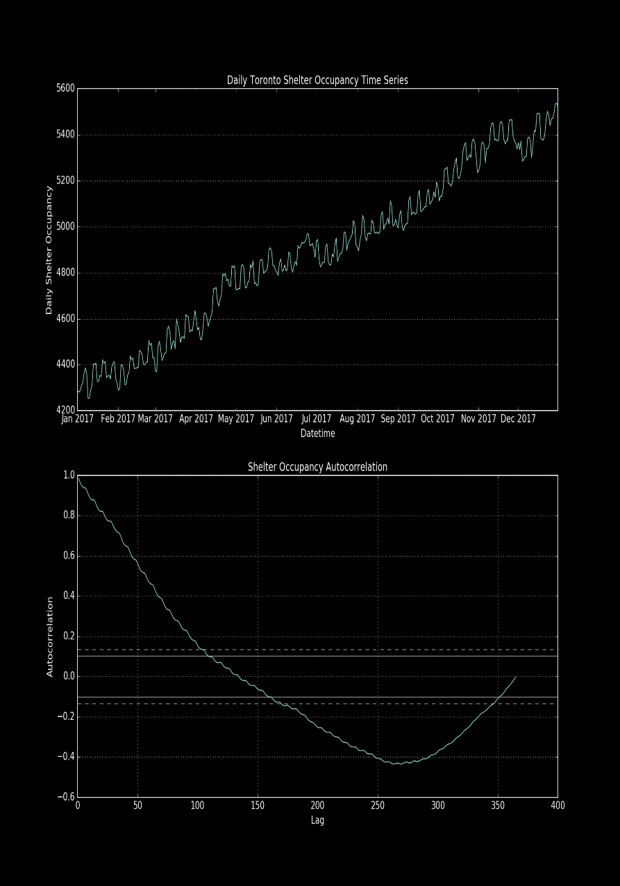

**Fig. 2.1 Occupancy time series and its autocorrelation**

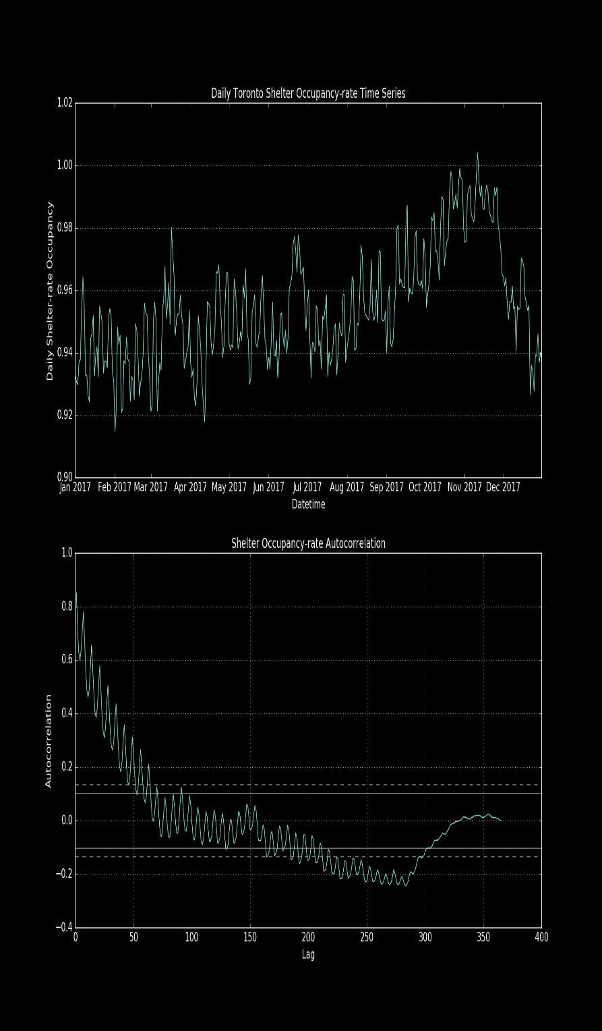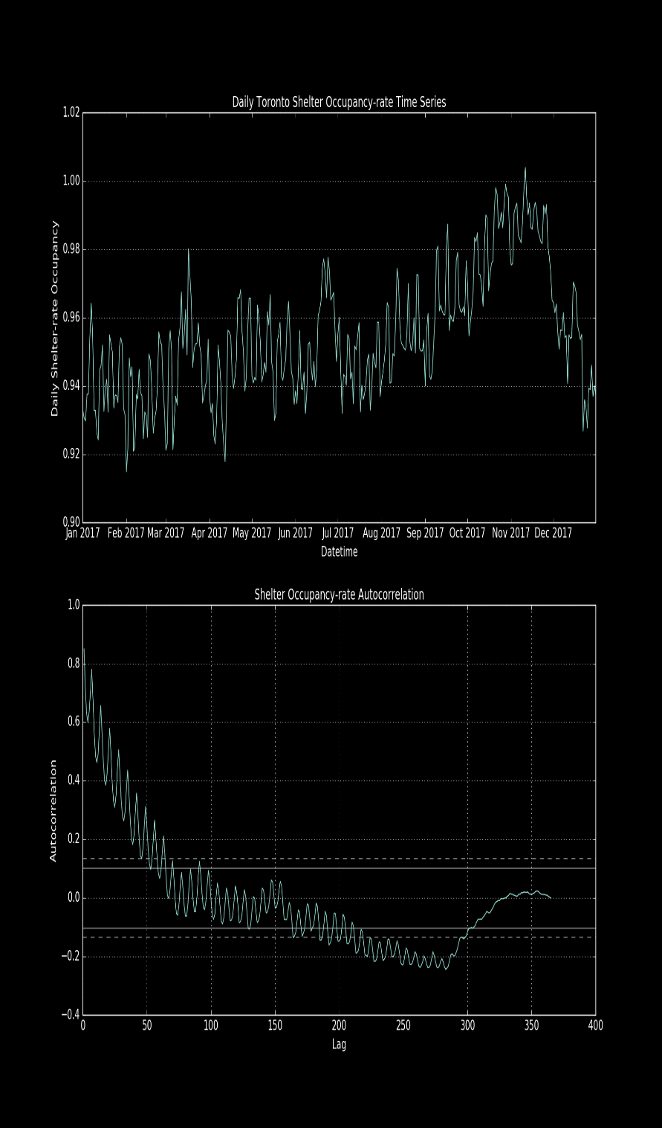**Fig. 2.2 Occupancy-rate time series and its autocorrelation**

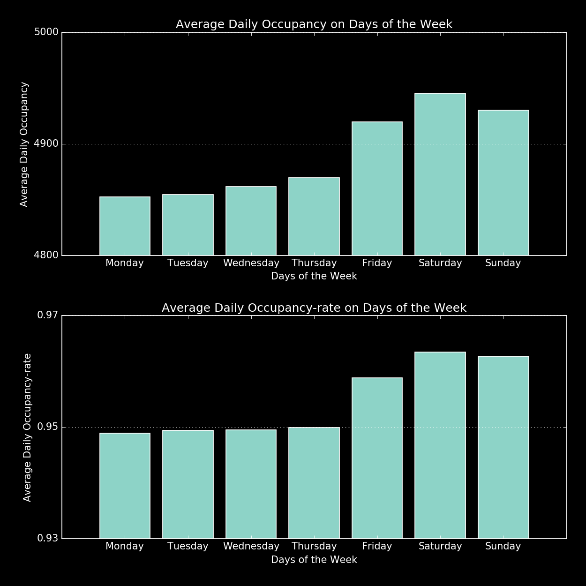**Fig. 2.3 Days of the week Occupancy and Occupancy-rate Averages**

## Shelter Variables vs Weather Variables Study

In this section, we will try to examine if there is any relationship between shelter variables and weather variables. For shelter variables, we choose capacity, occupancy and occupancy rate. On the other hand, we choose many daily weather features, namely temperature change (T_Delta), mean temperature, maximum temperature, minimum temperature, total precipitation, snow on ground, heat degree days and cool degree days. The correlation heat map between these factors are plotted in Fig. 3.1. From the graph, the highest correlation in the graph is mean temperature with occupancy, however, other temperature factors like precipitation, show no correlation to shelter variables.

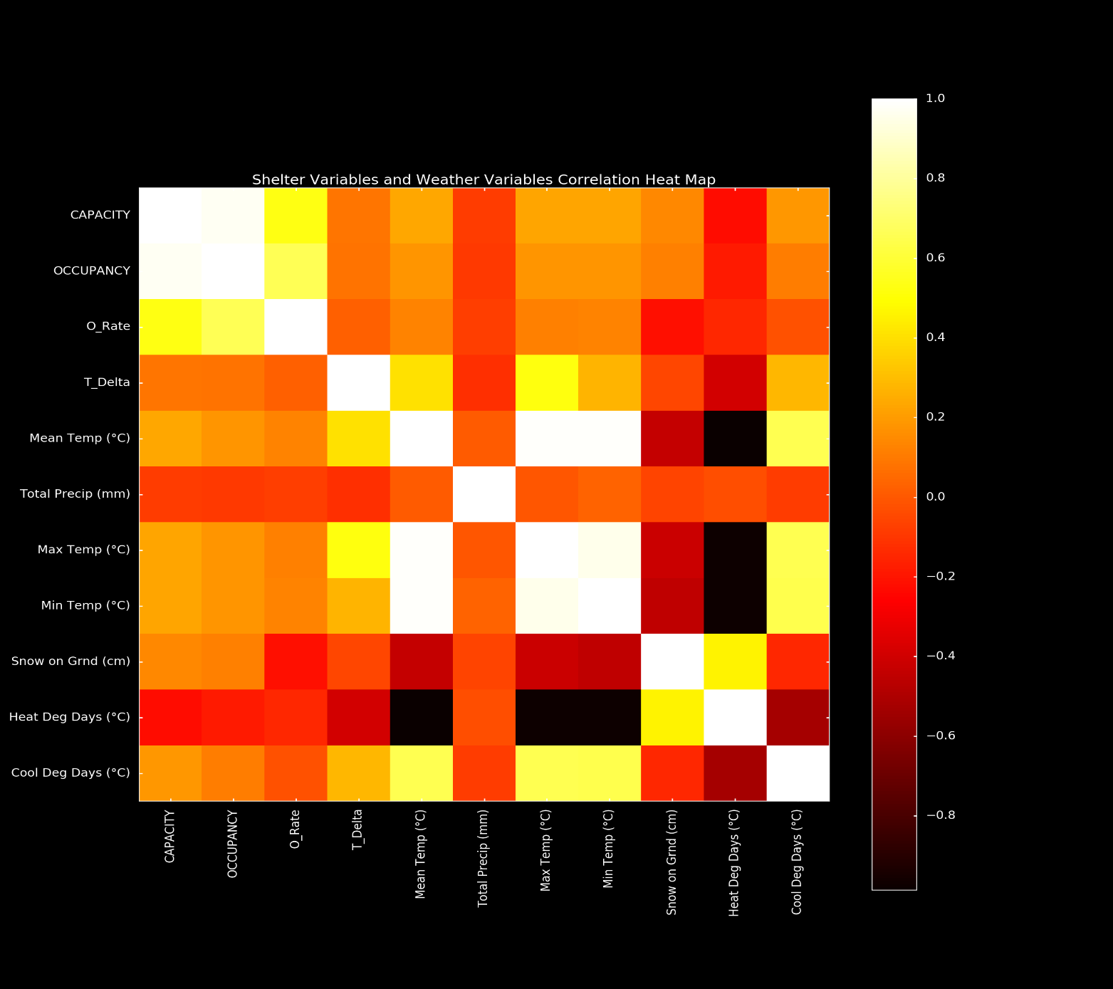

**Fig. 3.1 Shelter Variables and Weather Variables Correlation Heat Map**

To further explore this, we plot a scatter matrix for shelter and weather variables below in Fig. 3.2. In this graph, it depicts a both good positive and negative correlation between some shelter variables (capacity or occupancy) and some weather variables (mean temperature, max or minimum temperature).

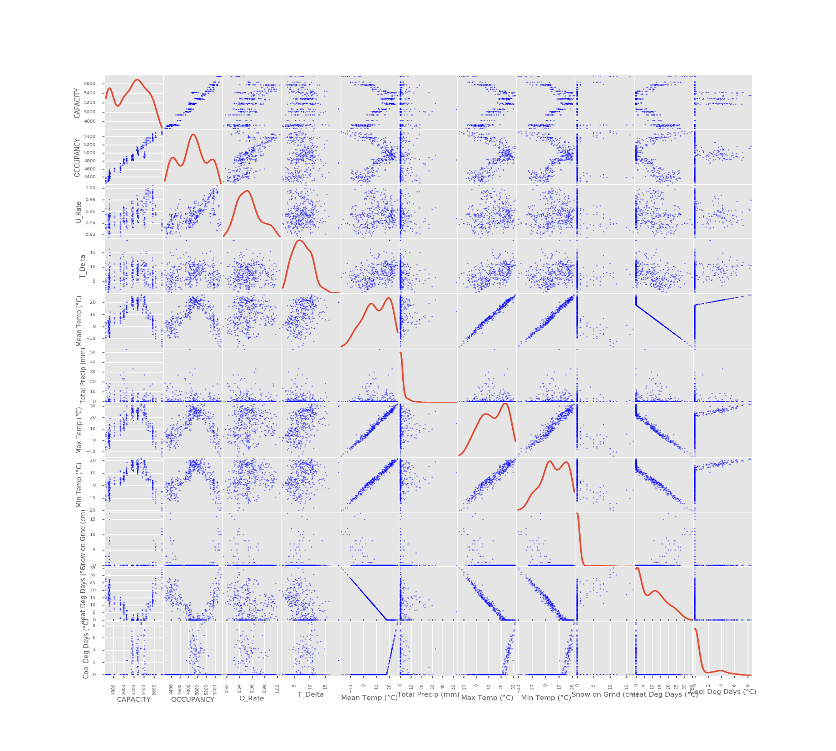

**Fig. 3.2 Shelter Variables and Weather Variables Scatter Matrix**

Because we are interested in occupancy of the shelters, we can take correlation between daily occupancy and mean temperature as an example. When we plot the first of the graph in Fig. 3.3 for the first half year’s scatter plot of occupancy and temperature, it seems like a positive linear correlation. A linear regression model is also made in the graph as a prediction of this trend. The same thing has been done for the second half year in Fig. 3.3, it shows a negative correlation and a linear correlation model is made for it as a predication.

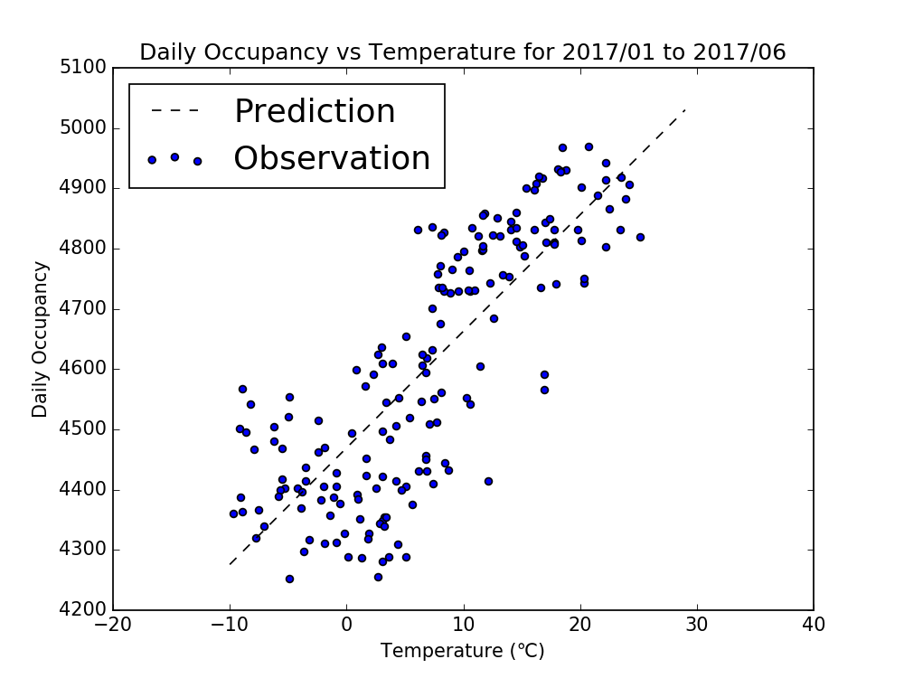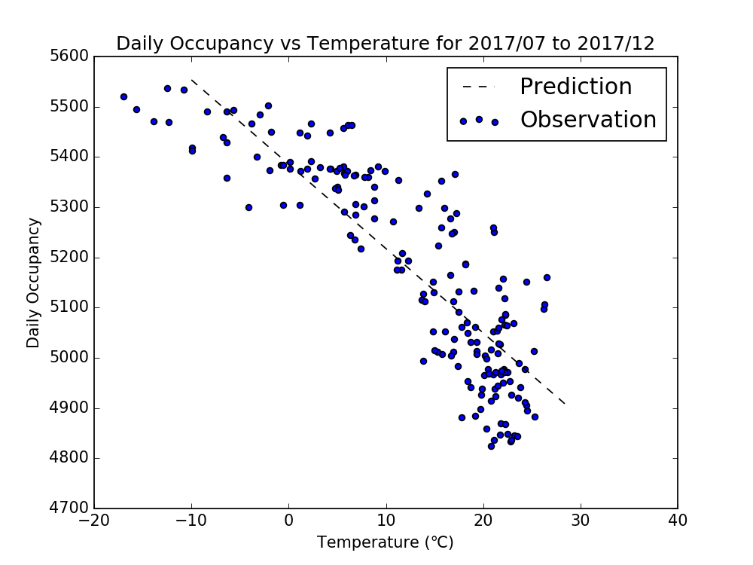

**Fig. 3.3 Shelter Occupancy and Mean Temperature Scatter Plot and Linear Regression Prediction**

However, how can it exhibit both positive and negative correlation for the same variable relationship? It does not seem to make common sense unless this means no correlation. Our conclusion is this, in fact since the overall occupancy is climbing over the entire year in 2017, it doesn’t matter if temperature increase or decrease. If you consider the mean temperature, it grows for the first 6 months and decrease over the last 6 months. The true correlation is positive correlation between the occupancy and date, not the temperature. The reason for it might be that shelters in city of Toronto is so in demand and predominant factor for now is not weather but the need for shelters. Whenever there are new capacities, they will be filled quickly. The occupancy dependency on temperature or weather factors will only start to exhibit when the need of the shelters is saturated.

# Sector Analysis

In this section, we will provide an analysis of homeless shelter capacity and occupancy for the family, male adult, female adult and youth sectors.

## Sector Analysis – Families

The ability of Toronto area shelters to accommodate families can be observed in Figure 4.1 and Figure 4.2. Although capacity remained relatively constant over the first three months of 2017, occupancy increased significantly over the same period. Homeless shelters responded by significantly increasing capacity over the remainder of the year. Overall, capacity and occupancy experienced a 94% (Range: 1018-1980) and 76% (Range:1150-2030) increase during 2017. The average capacity and occupancy was 1509 and 1562, respectively, over the period.

Occupancy statistics can be observed in Figure 4.3 and Figure 4.4. The occupancy rate fluctuated between 89.0% and 1.03%, with the average being 96.4%. Most notably, there appears to be a decrease in occupancy rates over the summer months. This could be due to weather changes, or the availability of alternative accommodation (e.g., cooling centres) that are not being tracked by the statistics we are using. The average daily occupancy and occupancy by day of the week seem to indicate a slightly higher demand during the weekend.

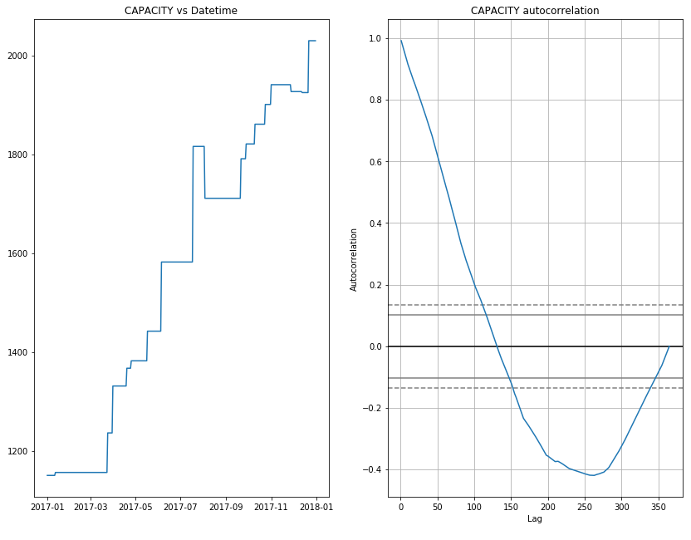

**Fig. 4.1: Bed Supply Capacity (Family Sector)**

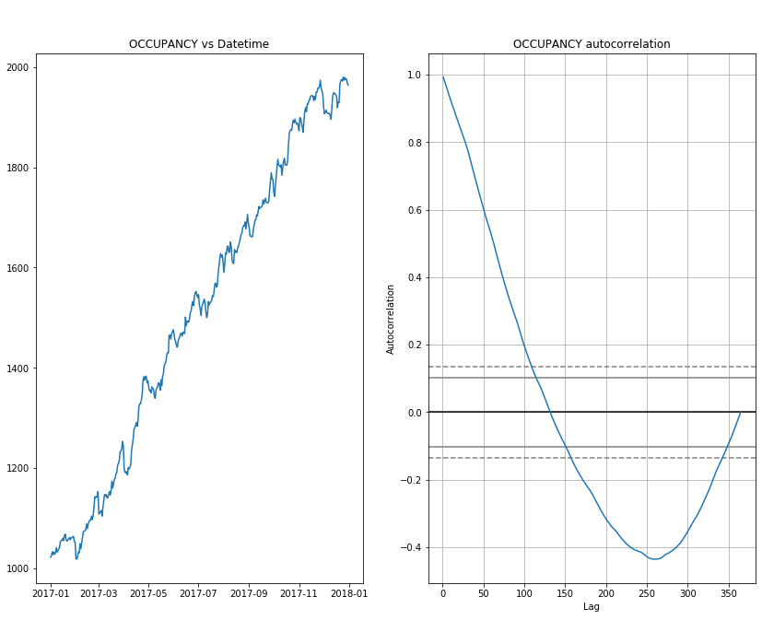

**Fig. 4.2: Bed Demand Occupancy (Family Sector)**

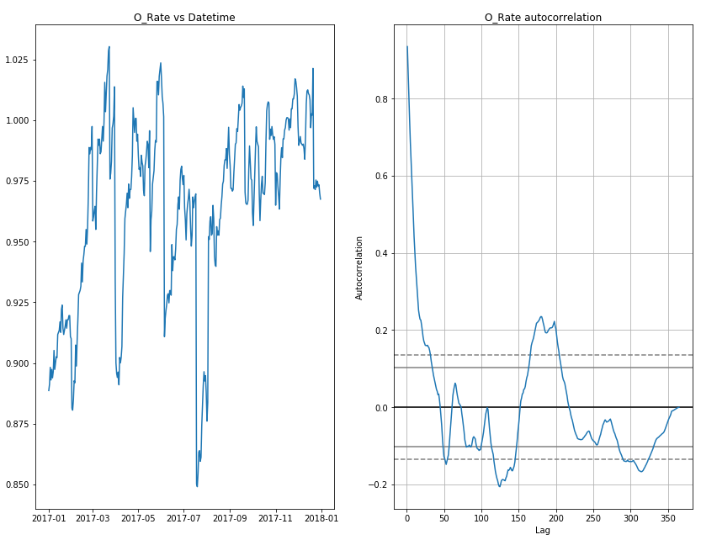

**Fig. 4.3: Occupancy Rates (Family Sector)**

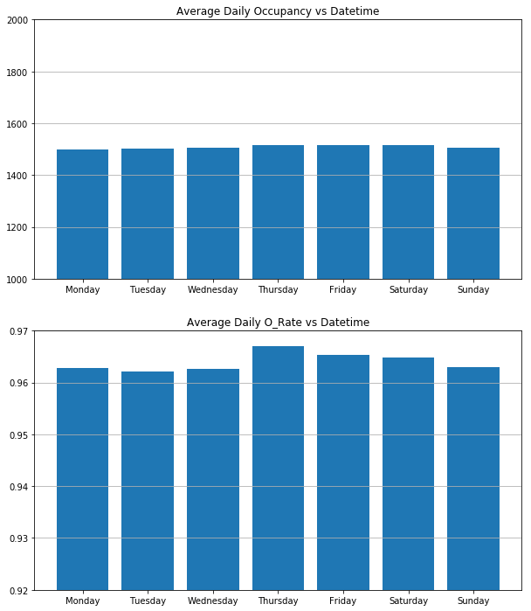

**Fig 4.4: Average Occupancy and Occupancy Rate by Day of Week (Family Sector)**

## Sector Analysis – Male Adults

The ability of Toronto area shelters to accommodate male adults can be observed in Figure 4.5 and Figure 4.6. Bed capacity and occupancy increased during the Spring, followed by a reduction over the summer months, and a sizeable increase during the fall (November). The year saw an increase in capacity and occupancy of 9.5% (Range: 1595-1748) and 6.8% (Range: 1706-1822). The average total occupancy and capacity over the year were 1681 and 1767, respectively.

Occupancy statistics can be observed in Figure 4.7 and Figure 4.8 . Occupancy rates fluctuate between 90% and 98%, with the average being 95%. Most notable is the decrease in occupancy rates over the summer months and at the end of the year. The average daily occupancy and occupancy rates seem to indicate a slightly lower demand for spaces during the weekend.

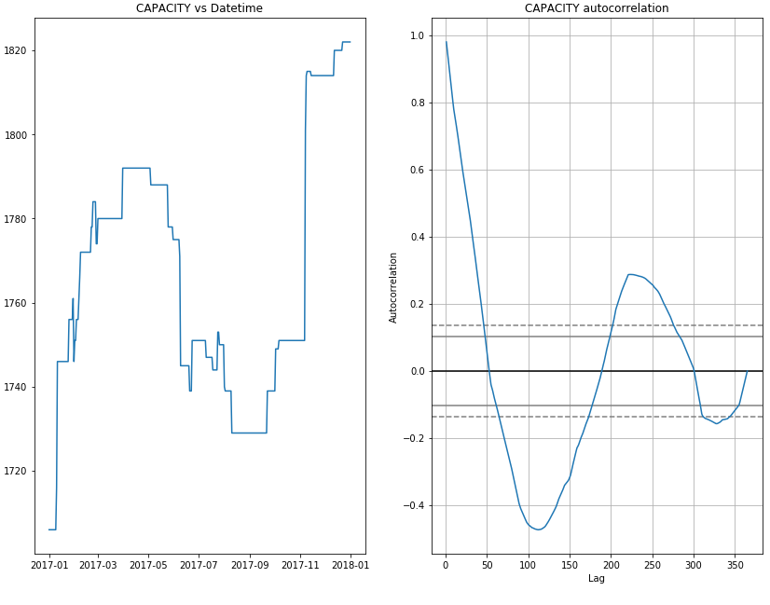

**Fig. 4.5: Bed Supply Capacity (Male Sector)**

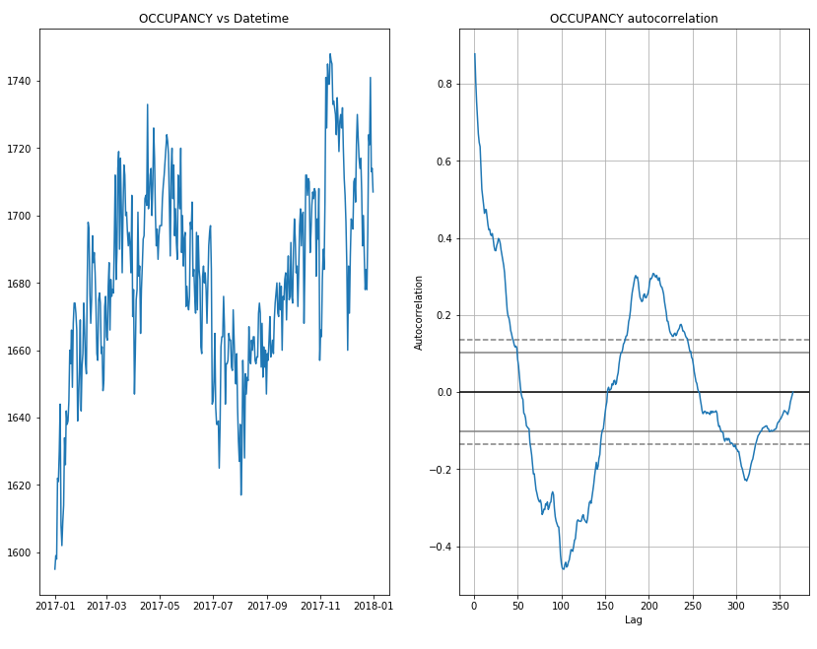

**Fig. 4.6: Bed Demand (Male Sector)**

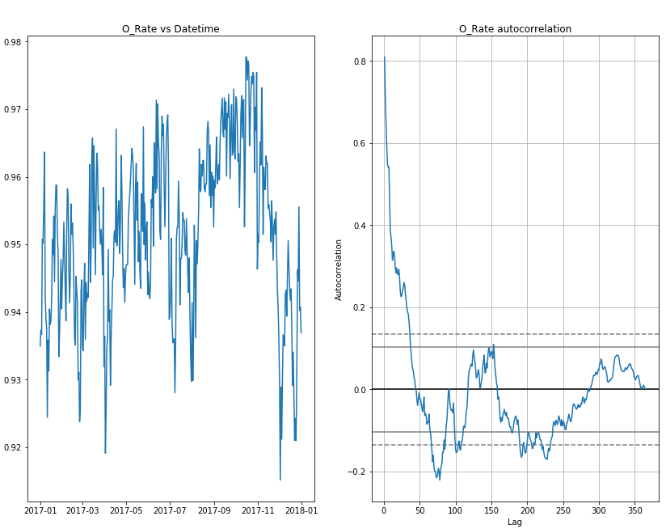

**Fig 4.7: Occupancy Rates (Male Sector)**

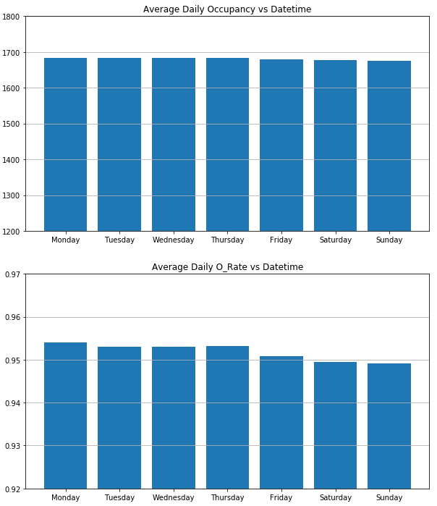

**Fig 4.8: Occupancy Statistics by Day of Week (Male Sector)**

## Sector Analysis – Female Adults

The ability of Toronto area shelters to accommodate the demand for homeless female adults can be observed in Figure 4.9 and Figure 4.10. Bed capacity and occupancy decreased during the spring, followed by a relatively stable period over the spring and summer months, and a subsequent increase towards the end of the year. The year saw an increase of capacity and occupancy of 10% (Range: 635-756) and 8.6% (Range: 685-767), respectively. The average capacity and occupancy were 687 and 706, respectively.

Occupancy statistics can be observed in Figure 4.11 and Figure 4.12. Occupancy rates fluctuated between 91.9% and 99.0%. The average occupancy rate was 97.3%. Most notable was the lower occupancy rate over the winter months. The average daily occupancy and occupancy rates seem to indicate no notable day to day trends.

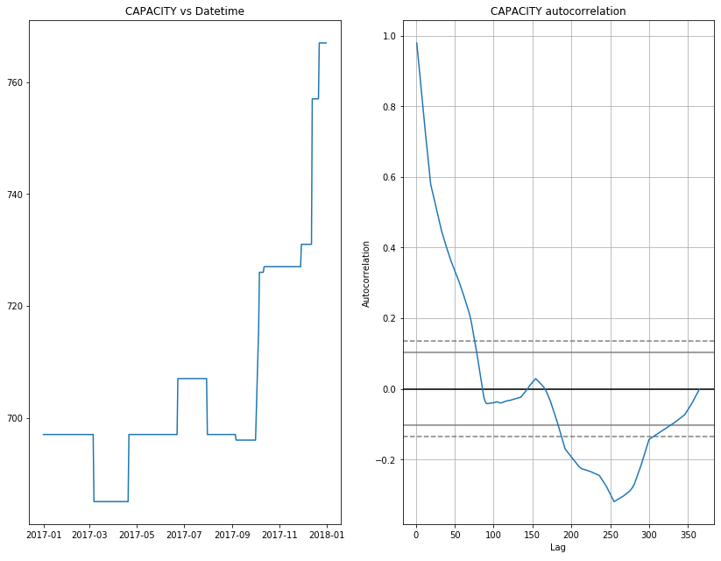

**Fig. 4.9: Bed Supply Capacity (Female Adult)**

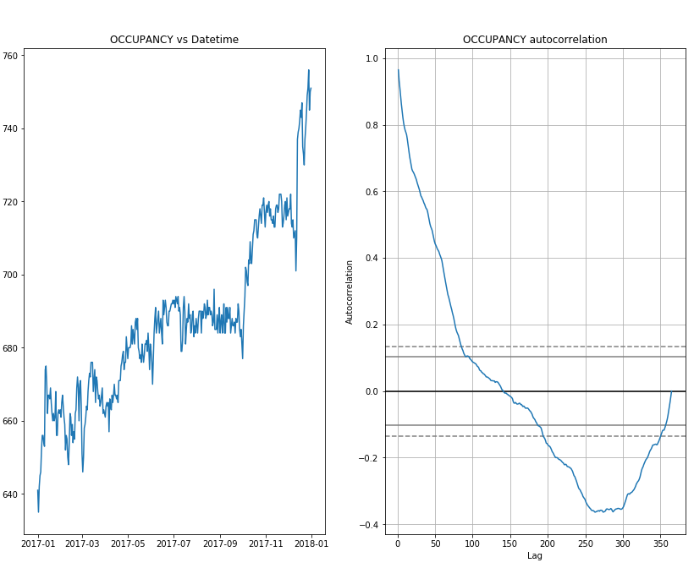

**Fig. 4.10: Bed Demand (Female Adult)**

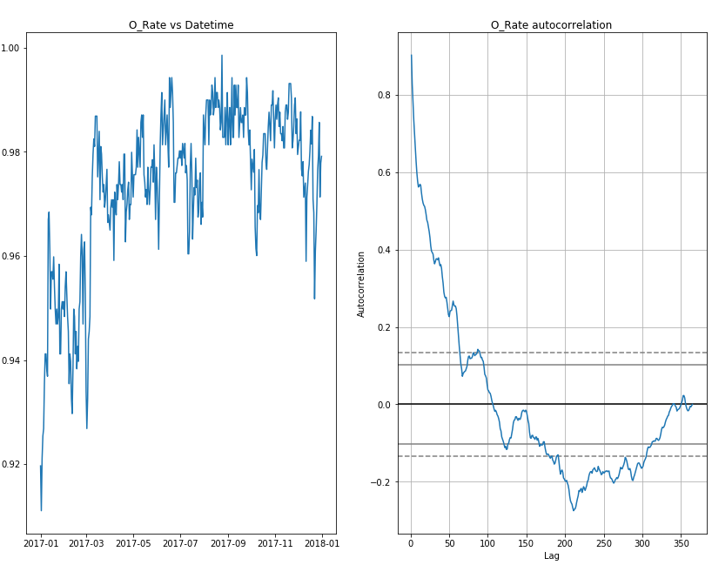

**Fig. 4.11: Occupancy Rate (Female Adult)**

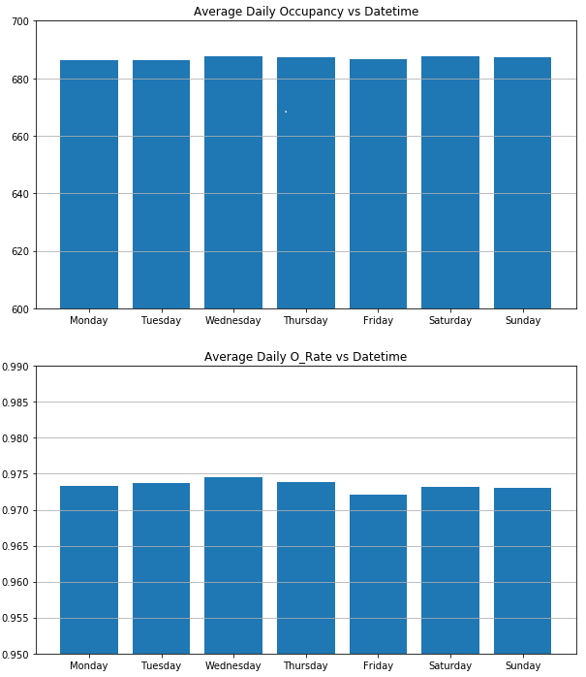

**Fig. 4.12: Occupancy Statistics by Day of Week (Female Adult)**

## Sector Analysis – Youth

The ability of Toronto area shelters to accommodate the demand from homeless youth can be observed in Figure 4.13 and Figure 4.14. Bed capacity was relatively fixed at 518 for the entirety of 2017 and was subsequently increased to 518 in 2018. Occupancy ranged from 418 to 518 throughout the period. The period experienced a percentage increase in occupancy and capacity of 6.4% and 1.4%, respectively.

Occupancy statistics can be observed in Figure 4.15 and Figure 4.16. Occupancy rates fluctuated between 94% and 99.8%, with limited monthly variances. The average occupancy rate was 97.1%. The average daily occupancy and occupancy rates seem to indicate no notable day to day trends.

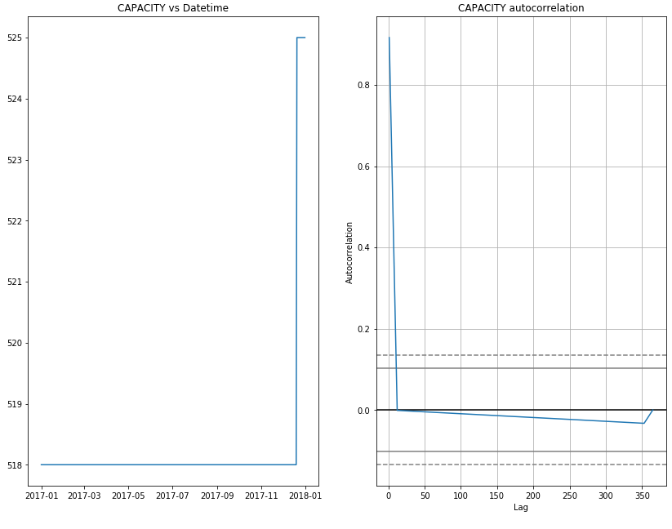

**Fig. 4.13: Bed Supply Capacity (Youth)**

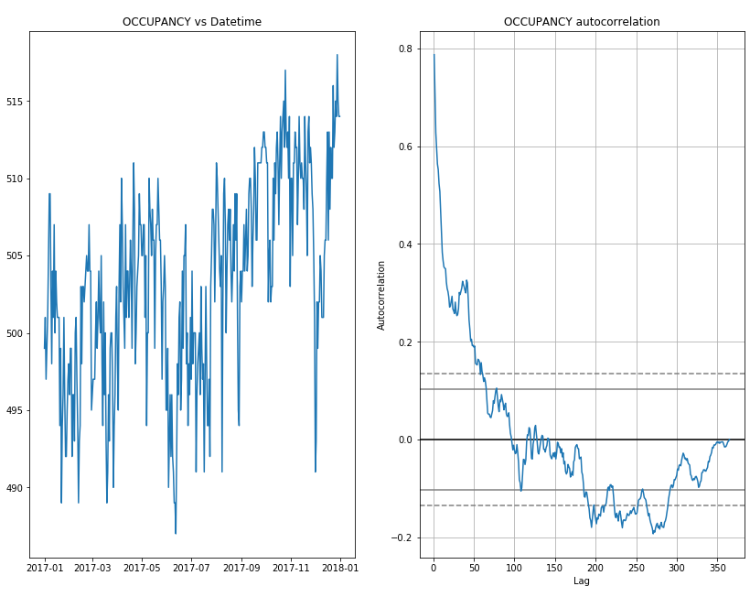

**Fig. 4.14: Bed Demand (Youth)**

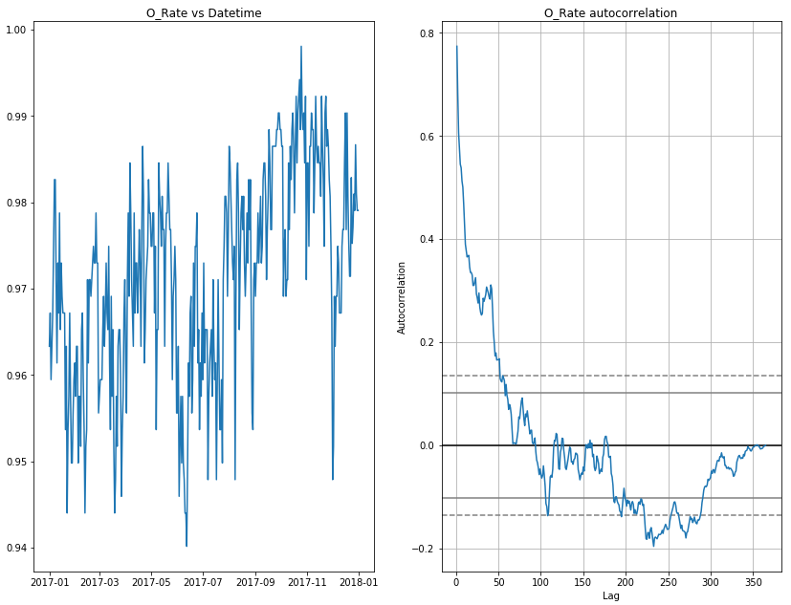

**Fig. 4.15: Occupancy Rate Statistics (Youth)**

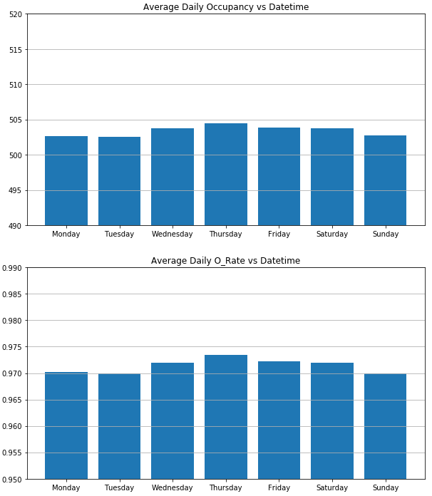

**Fig. 4.16: Occupancy Statistics by Day of Week (Youth)**

## Sector Analysis – Co-ed sector

City of Toronto operates shelters that are tailored to different group of people. Co-ed shelter data is independently analyzed to understand trends and patterns in shelter occupancy, and the data is analyzed with weather data to test the hypothesis.

First, shelter capacity for Co-ed increases from spring to summer but sharply decreases in the months of September and October. More capacity means more beds are available for use and it appears that more beds are available during summer months. Autocorrelation for capacity is useful to predict how many beds might be available based on recent days or weeks as it shows strong autocorrelation; a linear positive autocorrelation up to lag 50 days which means shelter availability in near future can be predicted. (Figure 4.17)

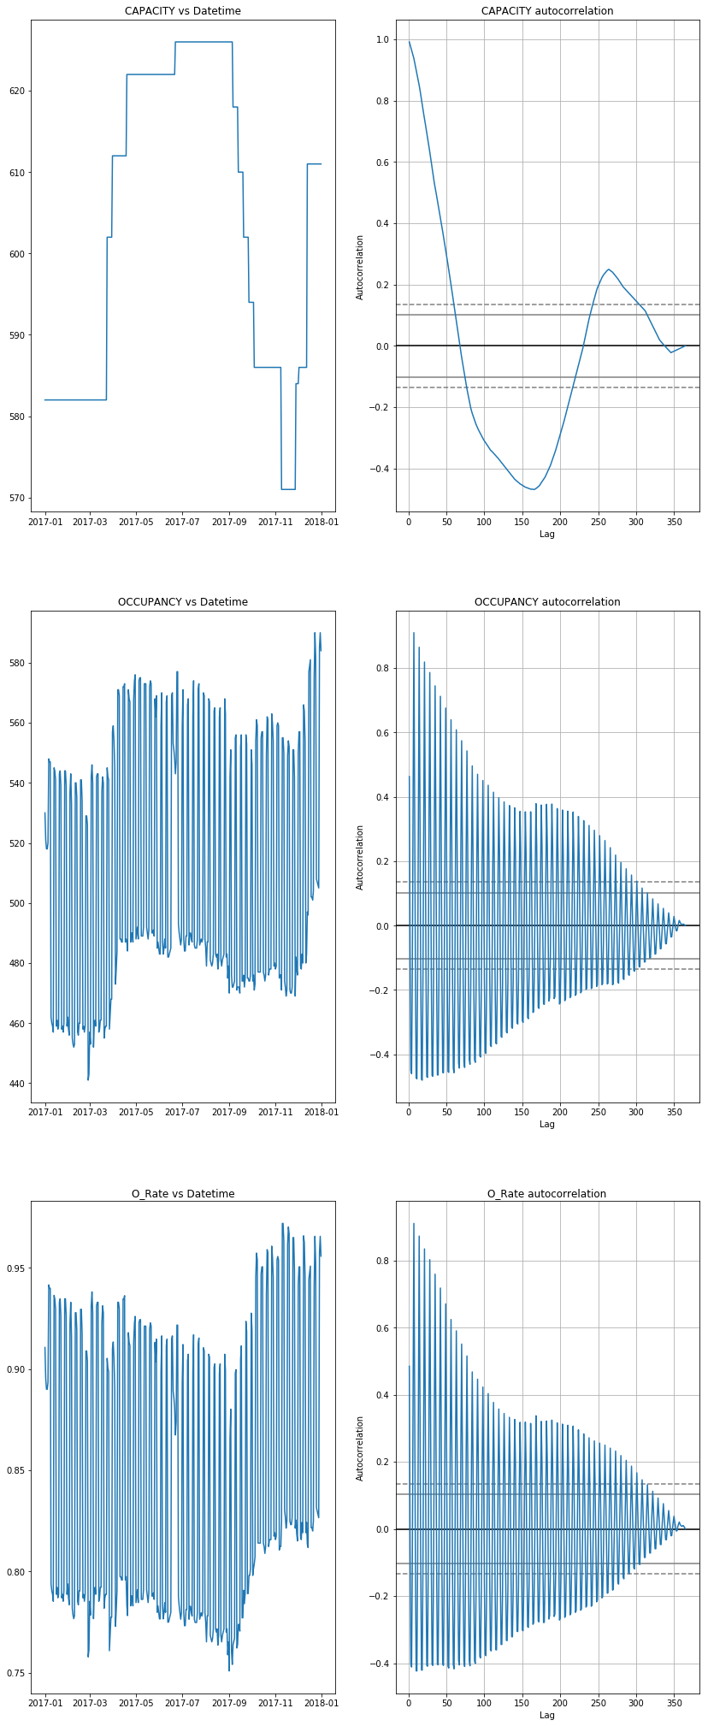

*Fig. 4.17 Occupancy and Capacity vs Data Time and Autocorrelation plot*

The shelter occupancy data for Co-ed show some interesting patterns. First, up and down spikes shown in the plot can be explained since it is daily shelter use data as people come and go causing the daily number to fluctuate. For general occupancy trends, the number fluctuates and exhibits an upward trend over one-year period of 2017; showing almost 90% occupancy rate over time. The occupancy rate shows slight increase in usage in summer and winter months, similar to the shelter capacity data trend. The analysis shows that shelter capacity and occupancy is highly correlated. It appears that the demand for shelter is already quite high regardless of time as available beds are immediately used up. The occupancy autocorrelation plot depicts an interesting pattern which is not observed in other shelter sectors such as male, female only or family shelters. There are 7 cycles of up and down in a block of 50 day-lag, which show weekly shelter use pattern. Oscillating positive and negative autocorrelation can be explained by high usage on the weekend. A demand for Co-ed shelter increases on the weekend, shown as a positive autocorrelation and decreases on weekdays seen as a negative autocorrelation(Figure 4.17). This pattern can be easily depicted using a bar chart. (Figure 4.18)

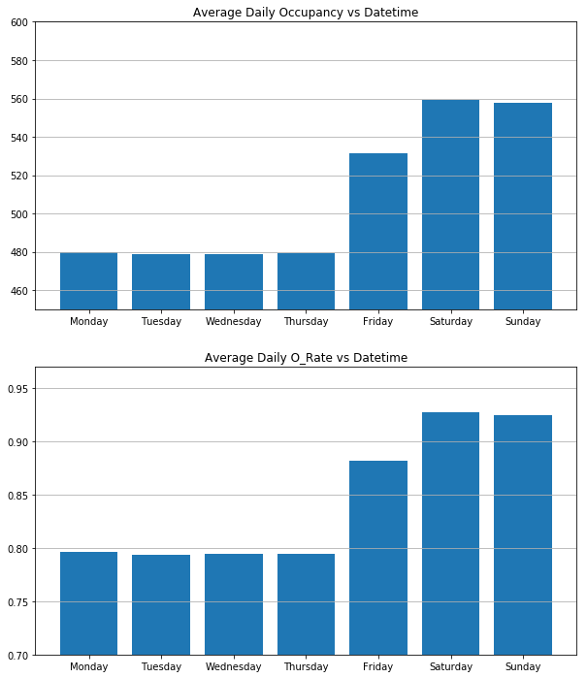

*Fig. 4.18 Weekend Occupancy trends*

Although Co-ed sector shelter usage has an interesting pattern that are not exhibited in other types of shelter, when it was studied with weather data, there wasn’t any statistically significant correlations, trends or patterns. (Figure 4.19)

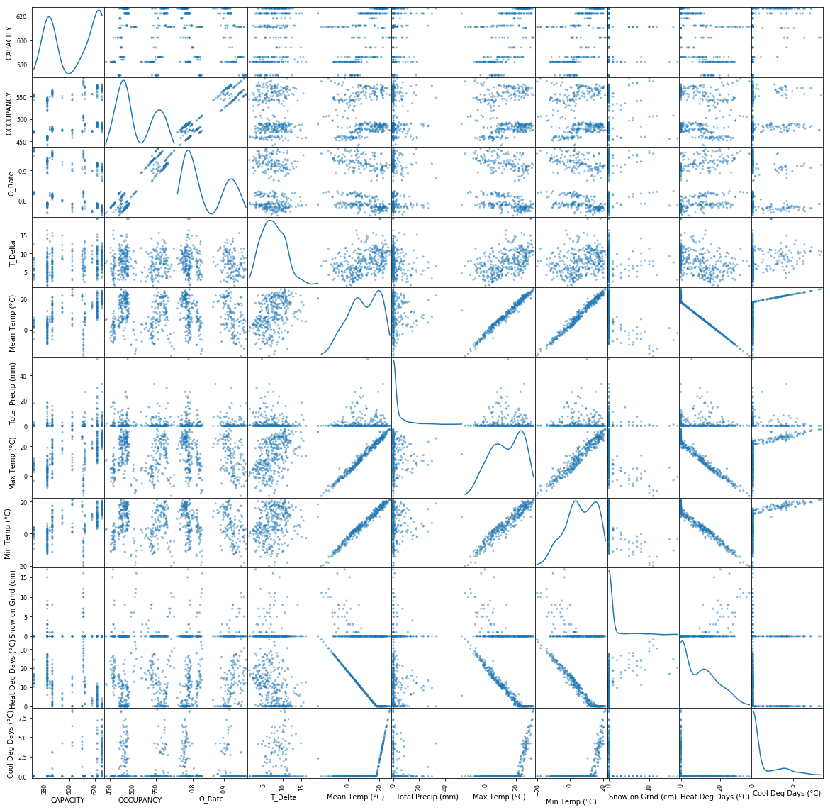

*Fig. 4.19 Shelter Occupancy use and weather data*

Earlier, occupancy rate was said to increase in summer and winter months, however with weather data such as daily mean temperatures, amounts of precipitation the study found no statistically significant correlation with shelter occupancy. Correlation heatmap (Figure 3.1) depicts this finding quite nicely.

# Conclusion

First, as in the general analysis section, there is no true correlation found between shelter occupancy variables and weather variables. The both positive and negative linear correlation between occupancy and mean temperature (Fig. 3.3) is because occupancy is growing over the entire year and while temperature is increasing and then decreasing through out the whole year. That means the true correlation is the occupancy over the date time, which is not the same with our hypothesis at the start of the project.

Second, although we haven’t find any pattern or correlations between shelter variables and weather variables, we do find an interesting weekly pattern in both daily occupancy number and occupancy rate (occupancy number over capacity number). We find this oscillation only exists in the Co-ed sector, and not in other sectors like Family, Men, Women and Youth. That means this oscillation is mainly contributed from the Co-ed sector. This can be illustrated in the stacked bar chart in Fig 5.1. In this chart, the average daily Occupancy number over the days of the week are similar for sectors like Family, Men, Women and Youth. It clearly indicates the oscillation solely come from the Co-ed sector.

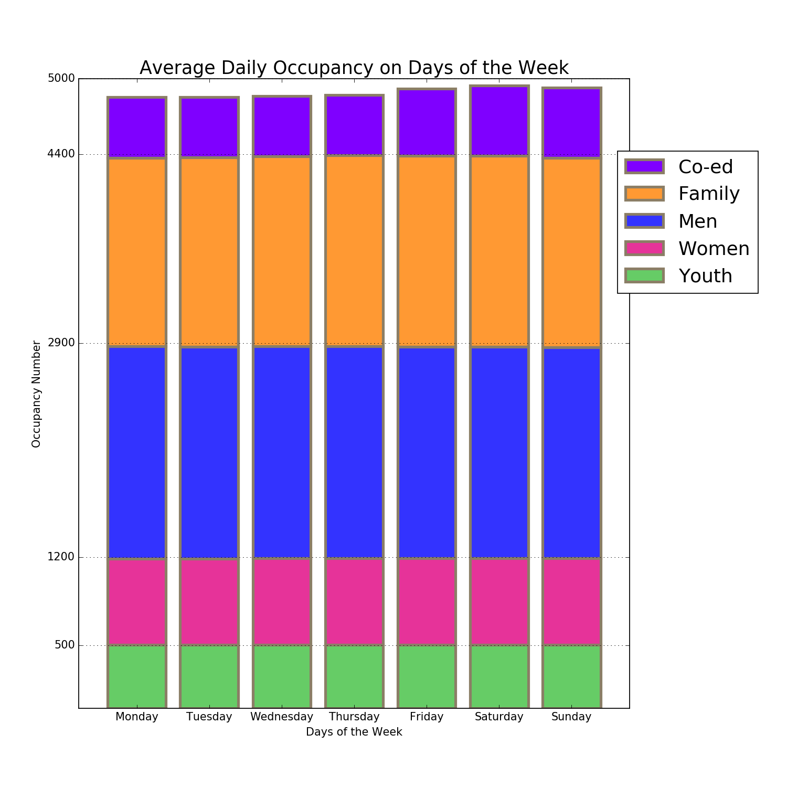

Fig. 5.1 Stacked Bar Chart for Average Daily Occupancy on Days of the Week for all sectors

In Fig. 5.2, the occupancy-rate follows the similar case as the above occupancy. The average daily occupancy-rates are almost constant over days of the week. In the graph, the average daily occupancy-rate order from high to low is Women, Youth, Family, Men and Co-ed, and rates other than Co-ed sectors are all above 95%. The Co-ed can be as low as 80% and will only climb over 90% over weekends. There appears to be a big difference in occupancy rate change over days of the week, compared with other sectors and very interesting. The reason for this trend might be that the Co-ed sector has people that can find a place to live over weekdays, but really depend on city’s shelter for the weekends. On the other hand, all other sectors are very steady in terms of occupancy-rate over days of the week and they are quite reliant on city’s shelter basically for everyday, with an averaged occupancy rate over 95%.

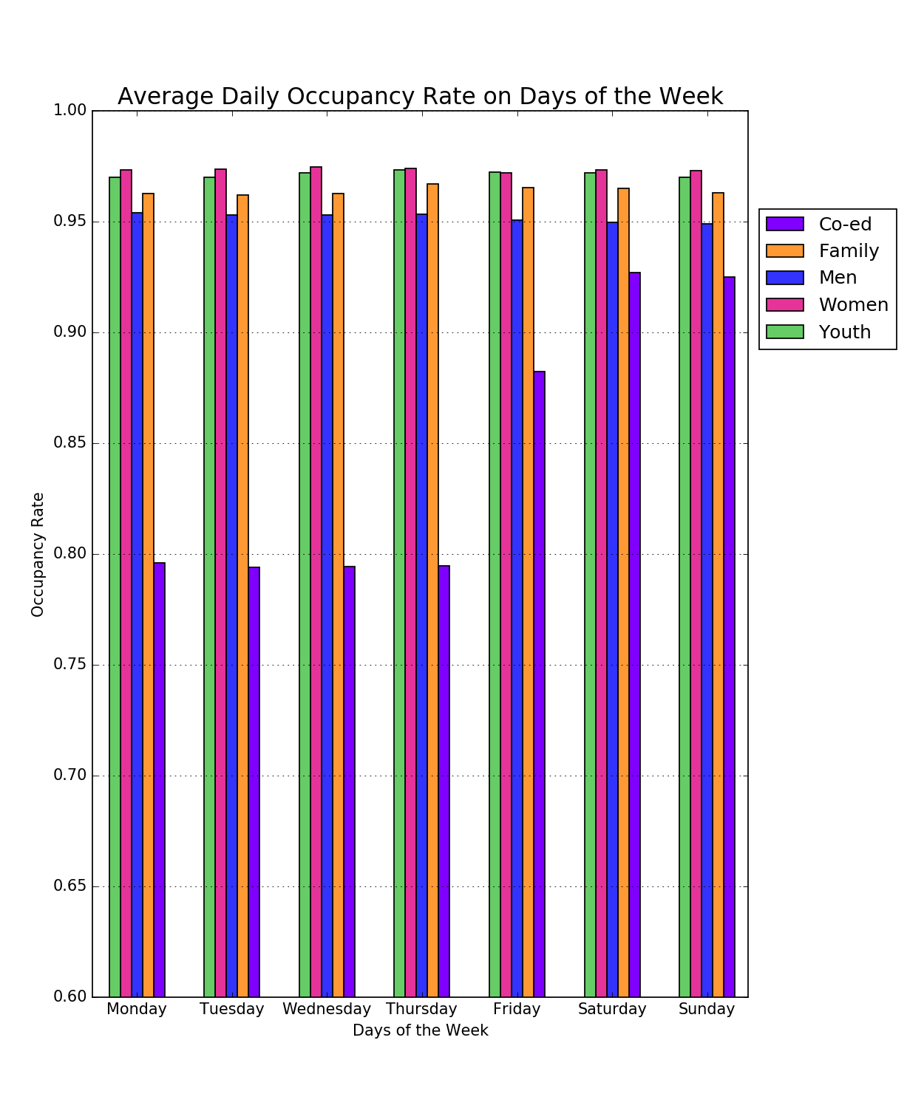

**Fig. 5.2 Side-by-side Bar Chart for Average Daily Occupancy-rate on Days of the Week for all sectors**

# 

# Appendix A

## Reference

1. <https://www.toronto.ca/community-people/community-partners/emergency-shelter-operators/about-torontos-shelter-system/see-our-shelters/>

2.<https://www.toronto.ca/city-government/data-research-maps/toronto-at-a-glance/>

3. <https://www.toronto.ca/city-government/data-research-maps/open-data/open-data-catalogue/#711ba031-b32b-3390-ce54-22c15ac6389f>

4. <https://www.ctvnews.ca/canada/cold-weather-crisis-facing-toronto-homeless-prompts-review-of-shelter-system-1.3742829>

5. <http://climate.weather.gc.ca/historical_data/search_historic_data_e.html>

6. <http://ocap.ca/wp-content/uploads/2017/08/out-in-the-cold-2016-ocap.pdf>

7. <https://globalnews.ca/news/4169193/toronto-refugee-claimants-shelter-system/>

8. <https://calgaryherald.com/news/local-news/cold-weather-doesnt-boost-homeless-shelter-numbers-study>

9. https://en.wikipedia.org/wiki/Precipitation

10. <https://www.investopedia.com/terms/h/heatingdegreeday.asp>

11. <https://www.investopedia.com/terms/c/colddegreeday.asp>

# Appendix B

## Sample Data:

Shelter Data for city of Toronto in 2017:

<https://raw.githubusercontent.com/yunfeibai123/3250-Class-Project/master/Toronto_Shelter_Occupancy_Data_2017.csv>

Weather Data for city of Toronto in 2017:

<https://github.com/yunfeibai123/3250-Class-Project/blob/master/Toronto_Daily_Weather_Data_2017.csv>

# Appendix C

## Sample Codes:

Python Code in Jupyter Notebook:

<https://github.com/yunfeibai123/3250-Class-Project/blob/master/3250_Project_Toronto_Shelter_Weather_Analysis.ipynb>